
Community Development Initiative (CDI)

CDI is initiated and funded by BP and its co-venturers in Baku-Tbilisi-Ceyhan (BTC), South Caucasian Pipeline (SCP) and South Caucasian Pipeline Expansion Project (SCPX). CDI program started in 2003 in 97 communities along the SCP and BTC Pipeline route and around SCPX facilities with the main goal Deepen positive relations between BP and communities along the BTC/SCP/SCPX pipelines and aboveground facilities investing in communities that demonstrate commitment to provide positive contribution for sustainable improvement in communities and to maintain and enhance sustainability of social-economic development.
Community Development Initiative
(2003-2017)
Facts and Figures
Gardabani district
94 rehabilitation projects
79 farmers – project beneficiaries
3 social enterprise project
117 small business projects

Marneuli district
4 rehabilitation projects
6 farmers – project beneficiaries
2 small business projects

Tetritskaro district
77 rehabilitation projects
46 farmers – project beneficiaries
5 social enterprise project
72 small business projects

Tsalka district
87 rehabilitation projects
185 farmers – project beneficiaries
7 social enterprise projects
69 small businesses projects

Borjomi district
34 rehabilitation projects
91 farmers – project beneficiaries
2 social enterprise projects
47 small business projects
Akhaltsikhe district
106 rehabilitation projects
207 farmers - project beneficiaries
5 social enterprise projects
195 small businesses

Adigeni district
24 rehabilitation projects
36 farmers - project beneficiaries
1 social enterprise project
54 small business projects

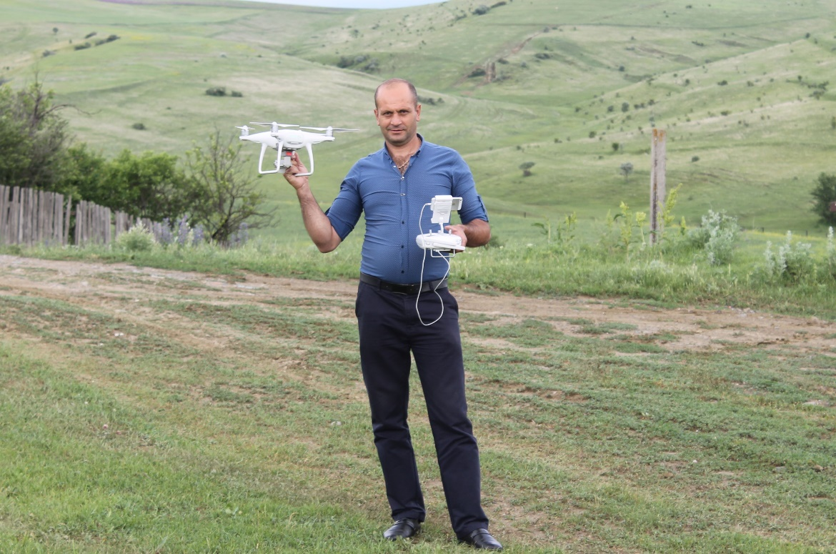
Cameraman
Tskruti, 2017
Sarkis Kuzatian is one of the most highly demanded photographers and cameramen in the region. Sarkis's small business was funded through CDI in 2017 and he purchased drone, a remote controlled aerial photography equipment. Due to its built in smart system, drone creates impressive bird-view footage from top and enables capturing unique scenes from inaccessible locations. As a result of such investment, Sarkis's service fee increased by 43% and demand for his services have grown by 1.5 times. Sarkis Kuzatian is now the top service provider for all major events in the region.
.

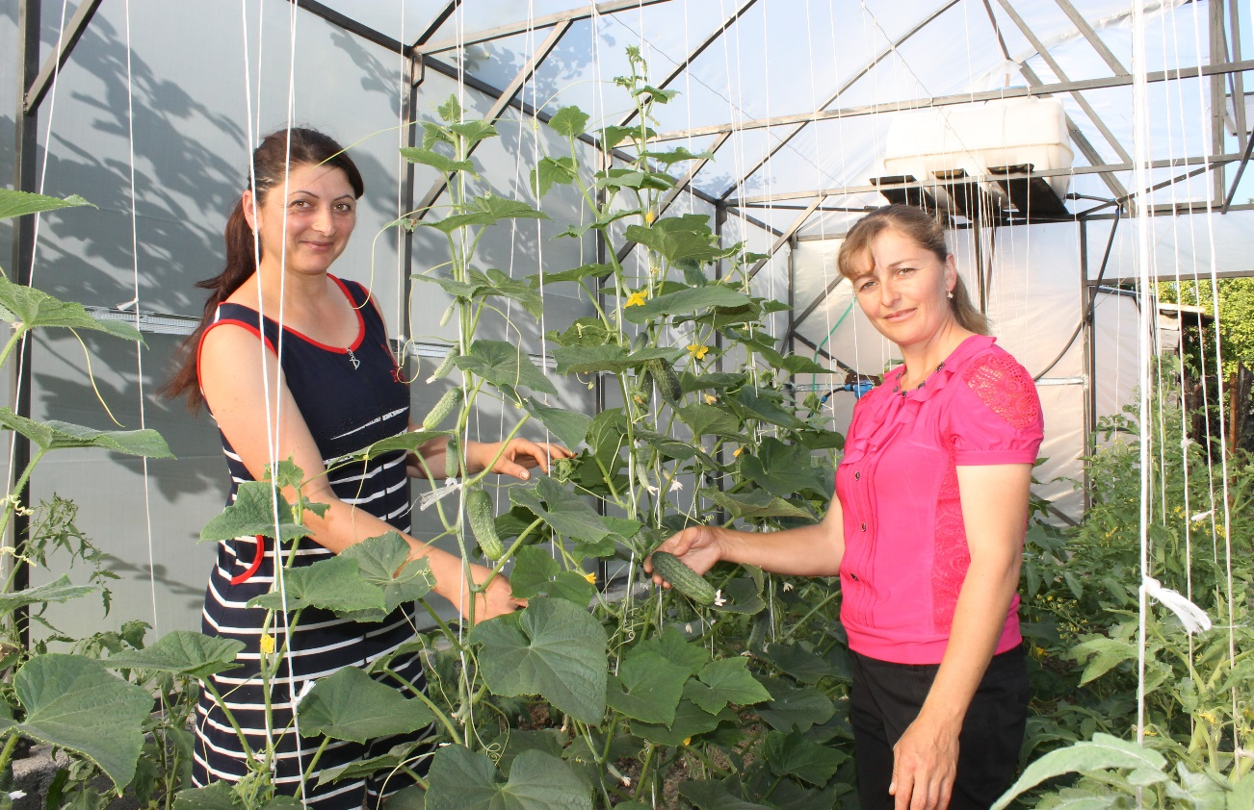

Greenhouses
Tsira, 2017
Two charming ladies from Tsira village - Nune Matevosian and Lusik Aslanain applied for CDI small business competition in 2016. Both of them received wining scores and awarded a grant to start vegetable greenhouse businesses. Nune and Lusik both had experience in cultivation of vegetables; however, poor irrigation capacity and low efficiency of production in open field encouraged them to invest in greenhouse and water-efficient modern drip irrigation system. As they work closely and share experience daily, the ladies admit they have a lot to learn and work hard to succeed in business. Their entrepreneurial spirit is a strong prerequisite for the long-term achievements. The difference in productivity between open field and drip-irrigated greenhouse is at least 60%. The income growth from business would roughly be of the same proportion. The greenhouse extends fresh vegetable season for locals and promotes modern farming technologies in to local communities.

